Background
Touch Control
Students | Jon Parcien, Rafael de Comas | Fall
Students | Jon Parcien, Rafael de Comas | 2019
Advisors | Dr. Bassem Alhalabi | 2019
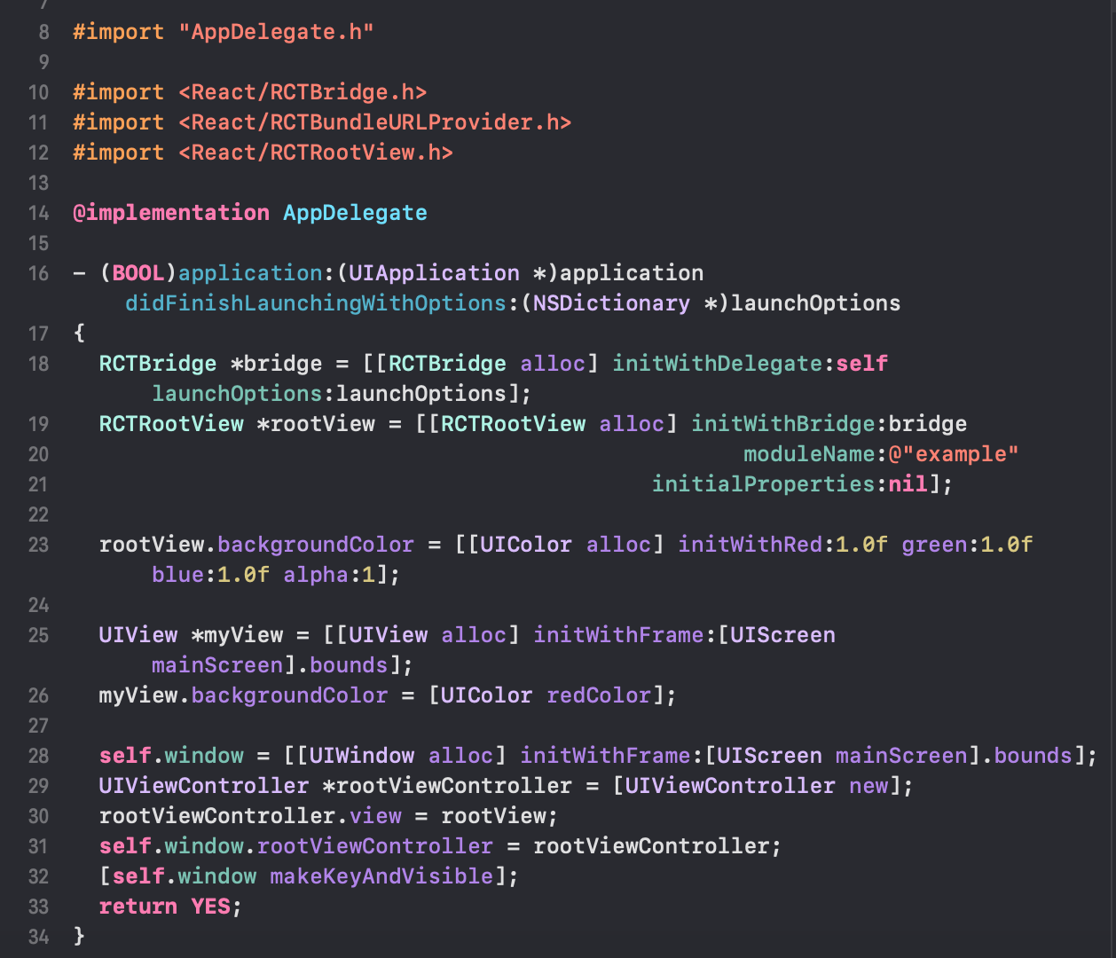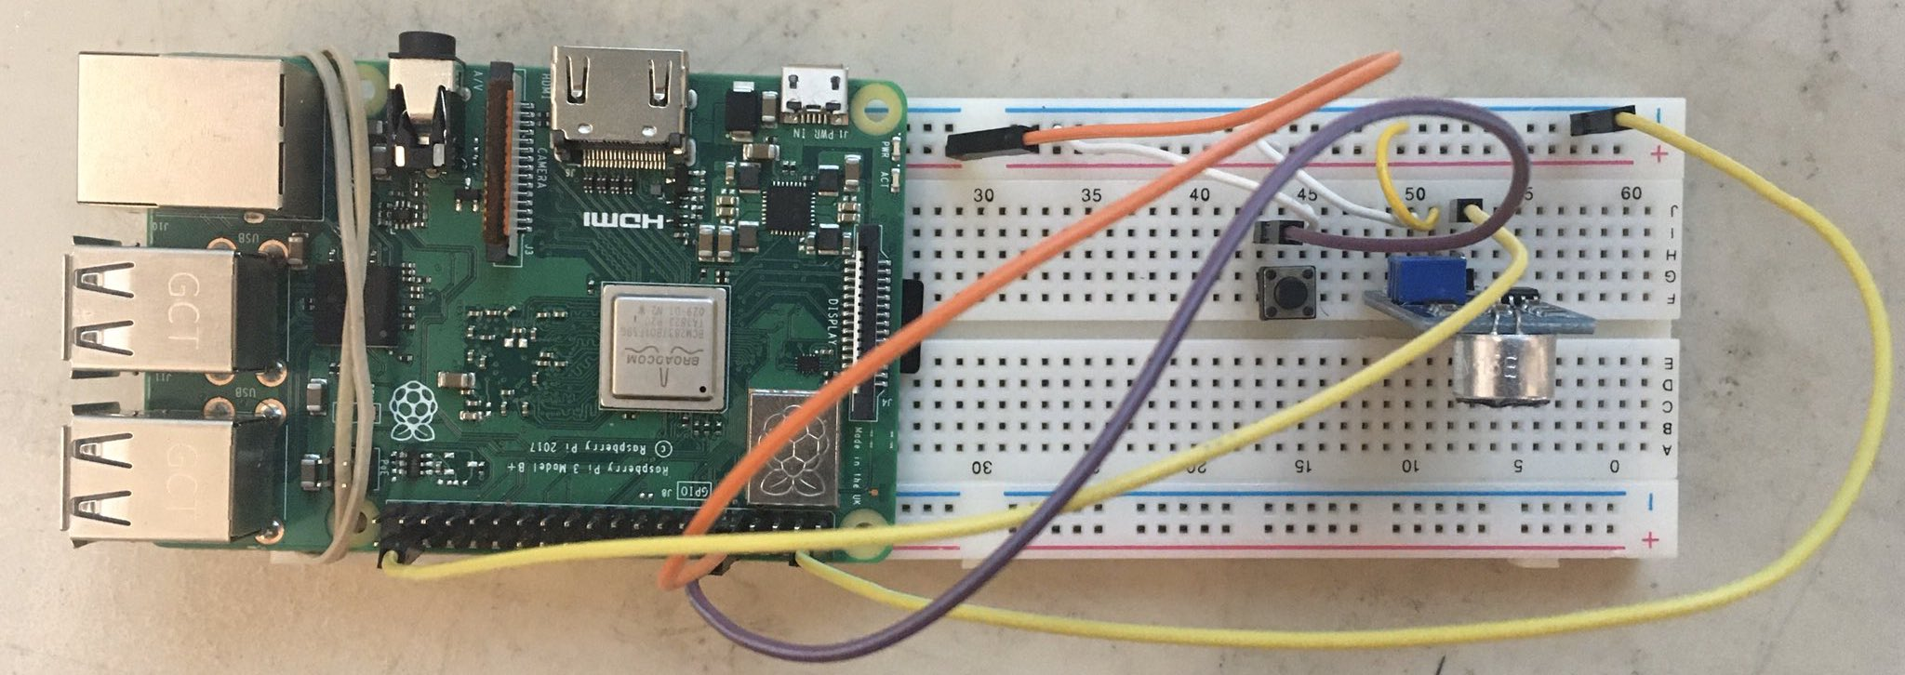
Jon Parcien and Rafael de Comas introduced Touch Control as their final for Embedded Systems Design in order to provide a photo taking application that could be operated through the Raspberry Pi 3 microcontroller. We had many qualities very important to our final, including:
- A fully operational Ios application that would function with or without the external hardware which provided all features of a smart phone camera.
- An easy-to-use button input connected to the Raspberry Pi that would take photos from the application with or without flash via Bluetooth connection to the phone.
- An ability to take photos or scan barcodes from the camera provided within the application.

Description
The final project utilized the compilers Visual Studio Code and Xcode to create an application for the Iphone with the language Javascript. We also used Python for the Raspberry Pi’s API in communicating with the application following use through a 2-pin button input. The framework of our application and it’s may codes are from React Native.

Design Issues
We found that during the creation of the first application that we encountered multiple errors during compilation. This resulted in us not having a working application for many weeks as the semester went by. Eventually this lead to us having to start an entire new application from scratch in order to build our vision for Touch Control. We also struggled in cwireless button for the input which would eventually be scrapped in favor of a more simple button on the breadboard.

Things We Learned
This project was a great learning experience for us as we are both computer science majors and were working a little outside of our comfort zone. We worked with a new language in Python and on very little knowledge with Javascript as we had took on a very big project. We made mistakes, and we made up for them as we learned to work as a unit in creating something to be extremely proud of. We also learned much more about microcontrollers as we built upon the knowledge we gained in microporcessors.

Conclusion
In conclusion we are extremely happy with the final project even with the few failures to provide what was originally planned. This is down to our perseverance through a great struggle in providing an application that we could be very proud of. We also managed to provide the input button with all the features necessary and more. This class was an amazing experience for us both.

